Discussion on the resultant figure of 2.2 Hz
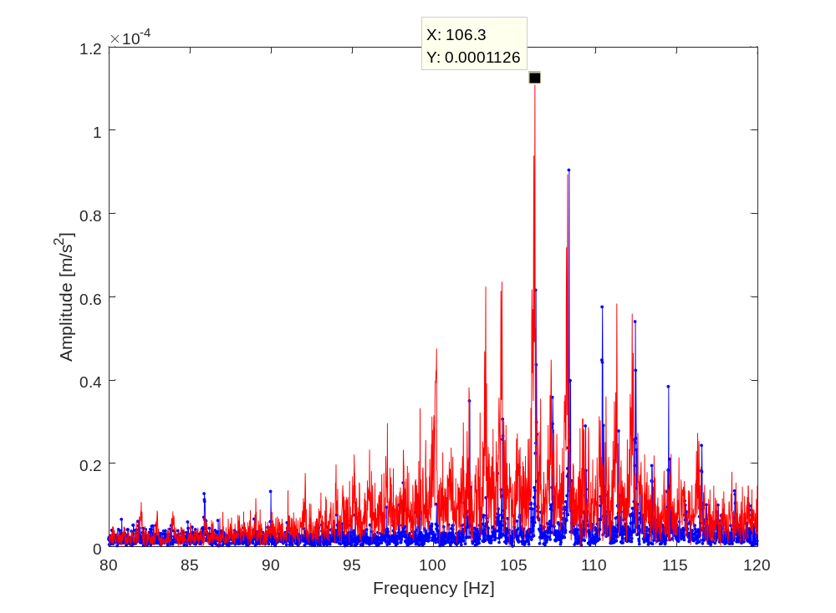
The carrier rotating frequency is approximately 1.0125 Hz. Abundant sidebands emerge around gear meshing frequency (109.35Hz). According to the reference, the equal load-sharing case (presented by the blue line) only has 4 and 4's multiples of carrier order, while the unequally load-sharing case (presented by the red line) has all integer multiples of carrier order.
However, the healthy case and unhealthy case manifest a similar pattern, with the difference that the whole amplitudes of the unequal load sharing spectrum are higher than equally one.
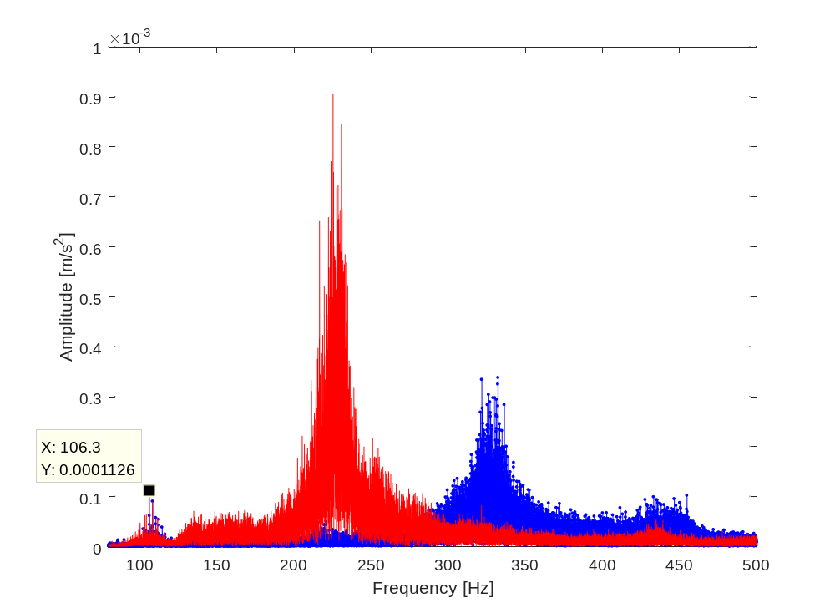
Another interesting point is the natural frequency of the test rig system shifts to a lower frequency domain with the existence of equal load-sharing.
And this phenomenon may also be able to be detected by the torsional vibration signal, which needs to be verified by further analysis.
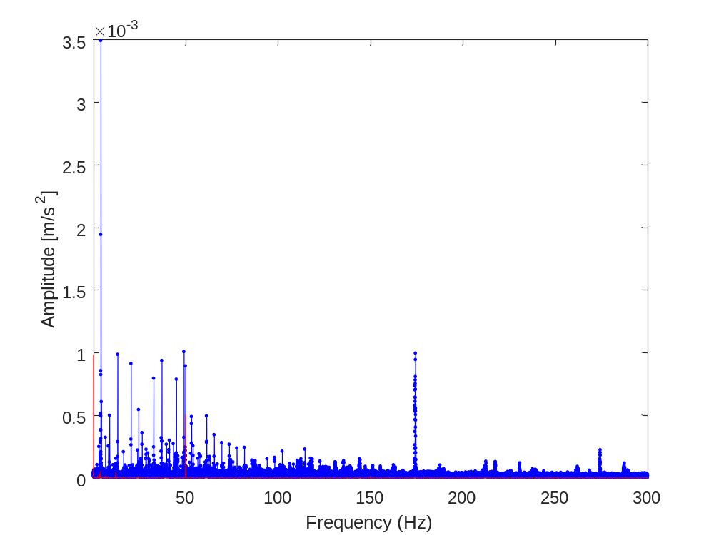
The above figure is the torque comparison. We can see the healthy amplitude overwhelms the unhealthy. I assume that the experimental data is wrong acquired.

